Toledo-Lucas County Sustainability Commission
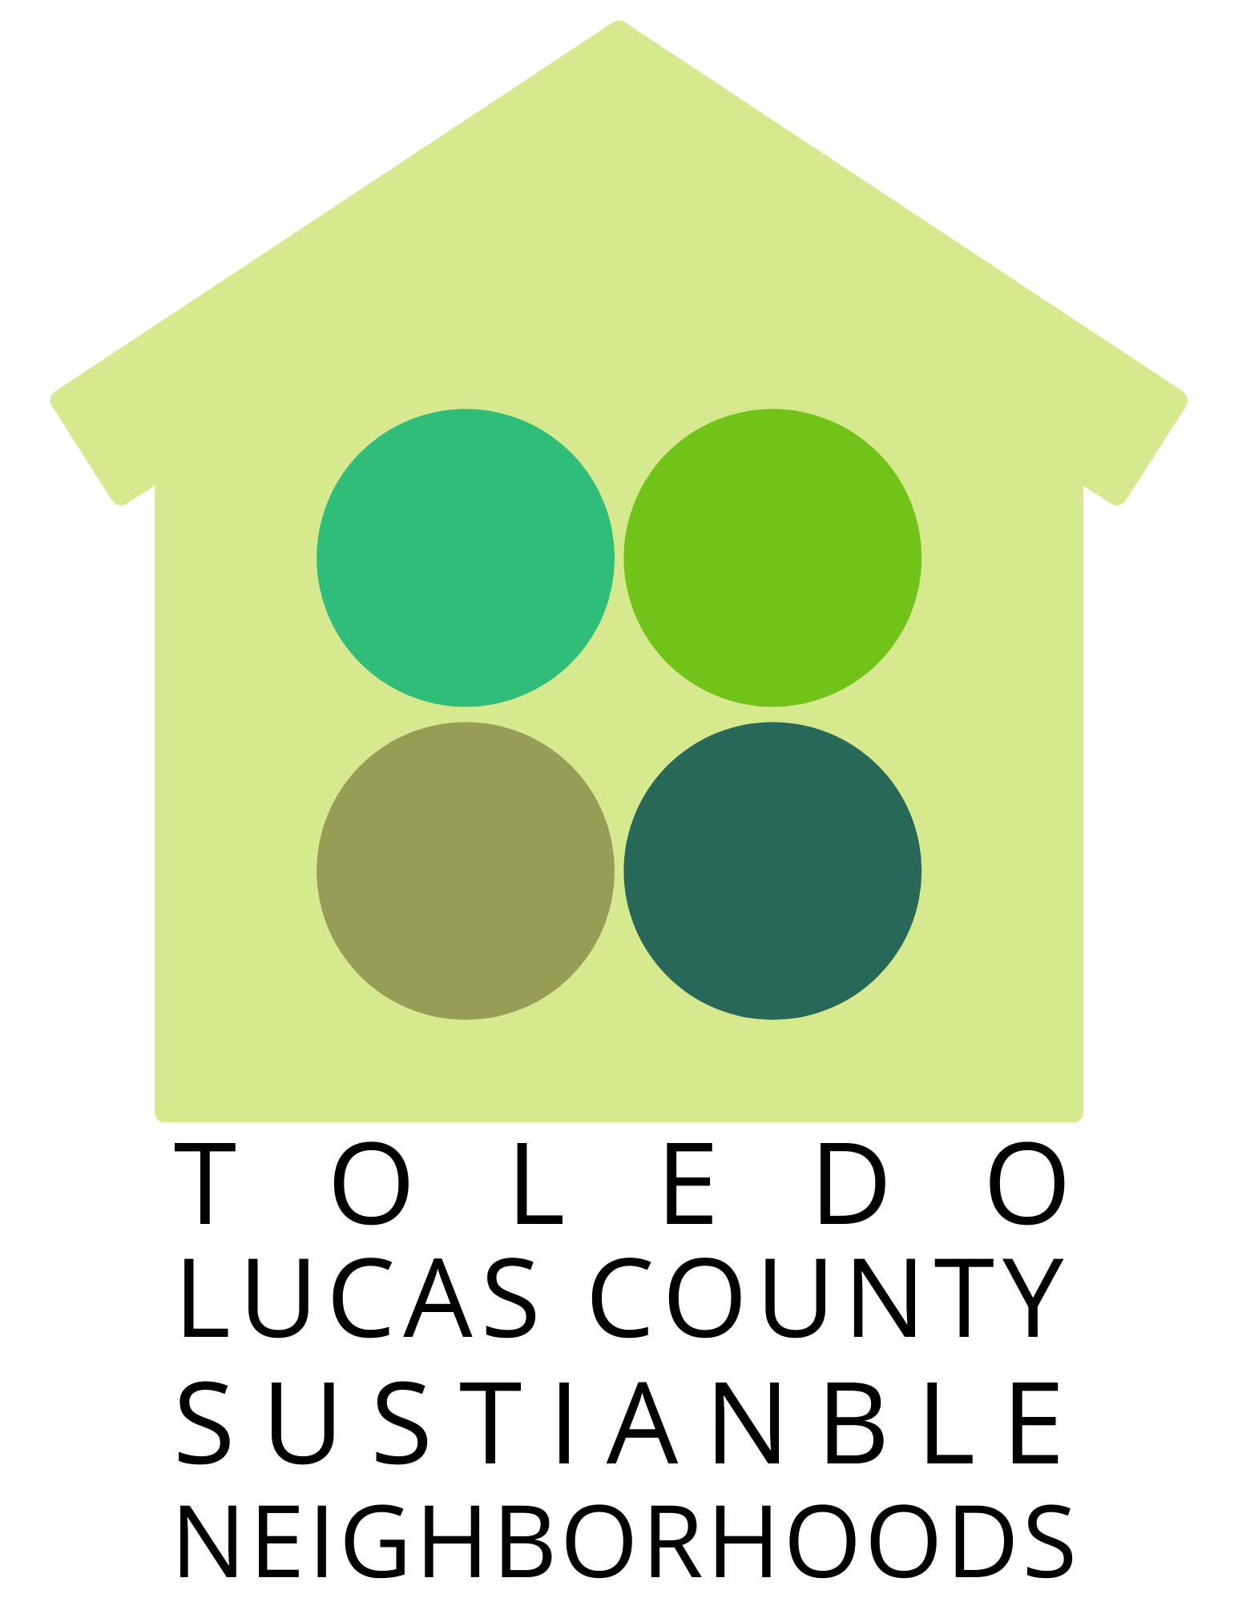
Sustainable Neighborhoods Grant Program

The Toledo-Lucas County Sustainability Commission has seed funding available for up to $1,000 per project. Funding will be awarded to groups or organizations looking to implement or continue projects that lead to increased sustainability for their neighborhood or community. Sustainability includes consideration of social, environmental, and economic factors that support neighborhood resiliency. Creative projects that capitalize on community assets are strongly encouraged. The goals of this funding opportunity are to promote sustainability in our region through place-based engagement at the neighborhood level.

Guidelines:
- Any neighborhood-based group is eligible to apply even if they are not a 501c(3) nonprofit organization (i.e. arts and culture groups, block groups, safety groups, neighborhood associations, business associations, youth organizations, faith-based groups, school-affiliated groups, etc.)
  - Note: for-profit entities, individuals, government agencies/departments, non-place-based organizations, and schools are not eligible to apply
  - Groups that aren’t a 501c(3) nonprofit organization must have a fiscal agent that is a 501c(3) nonprofit or charitable organization
- Funding requests may be made up to $1000; the budget should reflect the amount requested by the organization
- Funding is limited to work and projects in Lucas County
- Funds can be used for new or existing projects and for a long-term project or one-time investment
- Funds cannot be used for the organization’s operating or administrative budget
- Projects must be place-based and involve at least three unrelated project supporters connected to the neighborhood; ideally one or more person will live in the neighborhood
- Projects must make use of the strengths and assets that already exist in the community. This could include the working closely with resident volunteers, collaborating with other place-based organizations, and building upon existing strategic plans. Applicants are encouraged to think creatively about neighborhood assets and how they can be used to accomplish projects (i.e. vacant land is an “asset” that can be converted to a rain garden to decrease neighborhood flooding)
- Proposals will be evaluated on criteria including project goals and objectives, neighborhood location, incorporation of community assets, neighborhood resident involvement, creativity, reach, embodiment of sustainability, use of TLCSC’s Neighborhood Sustainability Toolkit in project design, and long-term project maintenance plans
- Grant duration is up to one year
- Follow-up is requested one year after disbursement of funds (photos, project challenges & successes, etc.) or upon completion of the project
  - Unused funds must be returned if not used at the conclusion of the funding term; extensions will be granted per recommendation of the selection committee
How to Apply:
Complete the following application and email it to tlcscommission@gmail.com or mail it to One Government Center: Suite 800, Toledo, OH 43604 by DATE. Applications will be reviewed by a selection committee made up of TLCSC Commission Members and community stakeholders. Successful applicants will be notified on DATE. If you have any questions, please contact Melissa Greene at 419.213.4530 or mgreene@co.lucas.oh.us
1. Group/organization name:
2. Describe your group/organization:
(What is your mission, who makes up your members, how long have you existed, and what are some past accomplishments)
3. Describe your neighborhood boundaries:
(a “neighborhood” can be defined as a group of 20 or more unrelated people or more than 10 homes/apartments in close proximity. If possible, please attach a map of the area.)
4. Primary contact person:
Name:
Phone:
Email:
Neighborhood Connection:
Website (if available):
5. Project supporters:
This project must involve three project supporters who will oversee and carry out the project; these are not just occasional volunteers. This can include the primary contact person. Ideally one or more person will live in the neighborhood.
- Name:
Phone:
Email:
Neighborhood Connection:
- Name:
Phone:
Email:
Neighborhood Connection:
- Name:
Phone:
Email:
Neighborhood Connection:
6. Fiscal agent information:
If you do not have your own 501c (3) federal tax-exempt status, you must have a fiscal agent. Please include a copy of your fiscal agent’s IRS determination letter and a letter on the fiscal agent’s letterhead stating that they agree to assume this role.
Organization:
Contact Person:
Address:
Phone:
Email:
7. Describe the project. Why is this project important for sustainability within your neighborhood? If this is a new project, explain how you will ensure integration into the community. If this is an existing project, explain the previous impacts and why additional funding is needed.
(approximately 400 words)
8. Describe how neighbors will be involved in implementing/continuing the project: (involvement of neighbors from all ages is encouraged):
9. Describe how this project will build upon or enhance existing community assets:
10. Describe how this project will be sustained and maintained:
11. Describe how TLCSC’s Neighborhood Sustainability Toolkit influenced or will be used in your project:
12. Project budget:

